**CHAPTER-1**

INTRODUCTION

In today’s fast-paced digital era, the interaction between humans and computers is evolving at an unprecedented rate, becoming more sophisticated, intuitive, and context-aware. Central to this evolution is the ability of machines to perceive and respond to human emotions, bridging the gap between emotion and technology. Facial emotion detection has emerged as a vital component in this transformation, offering the capability to understand and interpret human emotional states through non-verbal cues, specifically facial expressions. By accurately identifying emotions like happiness, sadness, surprise, or anger, systems can adapt and respond in ways that make interactions more meaningful and personalized.

The importance of facial emotion detection transcends mere convenience. In customer service, for instance, it can be used to assess client satisfaction in real-time, enabling companies to provide tailored responses that improve customer experience. In healthcare, emotion detection can be instrumental in monitoring patients' mental health, potentially identifying signs of depression, anxiety, or stress. In education, teachers and systems alike can assess student engagement or frustration, adapting teaching methods or content delivery accordingly. These diverse applications highlight the far-reaching implications of emotion detection technologies in both personal and professional spheres.

This project aims to implement a live emotion detection system using Python, OpenCV, and the FER (Facial Expression Recognition) library. By leveraging these open-source tools, we aim to create an accessible and efficient solution that uses a webcam to capture real-time video feeds. The system processes these inputs through machine learning algorithms capable of identifying and classifying a range of emotions such as happiness, sadness, surprise, anger, and more. By doing so, the project demonstrates how real-time emotion recognition can be achieved with minimal hardware, thus making the technology easily integrable into a variety of applications.

The growing field of affective computing—which focuses on the development of systems that recognize, interpret, and simulate human emotions—has expanded the possibilities of what emotion-aware technology can achieve. Applications range from virtual assistants capable of responding empathetically to users' emotional states, to interactive gaming environments that adjust difficulty or narrative based on the player’s emotional responses. These developments underscore the transformative potential of facial emotion detection and affective computing in enhancing the user experience by making machines more emotionally intelligent.

Moreover, integrating emotion detection systems into everyday life promises significant potential in industries like marketing and healthcare. Marketers could use emotion recognition to better understand consumer reactions to products and advertisements, allowing for more targeted and effective campaigns. In healthcare, emotion detection could serve as an additional diagnostic tool for assessing patients’ emotional and mental health, facilitating early intervention in cases of psychological distress. Beyond these sectors, the technology holds potential in areas like security, human resource management, and entertainment, offering insights that can drive decision-making and improve user experiences.

As technology continues to advance, the ability of machines to analyze and respond to human emotions will redefine how humans interact with computers and digital systems. In this context, real-time emotion detection offers a promising step toward more natural, empathetic, and context-aware human-computer interactions. By bridging the emotional divide between humans and machines, this project sets the stage for future innovations where computers not only serve functional roles but also respond to our emotional and psychological needs, ultimately creating more immersive, interactive, and human-centered experiences.

**CHAPTER-2**

**PROJECT OVERVIEW**

**The objective of this project**

is to design and implement a real-time facial emotion detection system that captures video frames, detects faces, and identifies emotions. Using a webcam, the system continuously streams live video and processes each frame to analyse the facial expressions of individuals. At the core of this system is the FER (Facial Expression Recognition) library, a powerful tool that leverages deep learning models to recognize various emotions such as happiness, sadness, surprise, anger, fear, and disgust.

By integrating computer vision techniques with machine learning, this project enables the system to not only detect facial features but also interpret the emotional states associated with those features. The FER library uses modern facial landmark detection and emotion classification algorithms to ensure accuracy and reliability. It is capable of detecting subtle changes in facial expressions, making it effective for real-time applications.

The system’s modularity makes it flexible for a variety of use cases. In educational settings, for example, the system could be used to monitor student engagement and attention by detecting emotions such as confusion or boredom during a lecture. In entertainment, it can track audience reactions to content, providing insights into viewer sentiment. It can also be applied in fields like customer service, where live emotion detection can assess customer satisfaction or frustration during interactions.

Furthermore, the system is scalable, meaning additional features can be integrated over time. Future improvements could involve expanding the range of detectable emotions or integrating sentiment analysis to provide more comprehensive feedback.

**Ethical Considerations**

As the system evolves, it is essential to address ethical considerations surrounding privacy and consent. Implementing clear guidelines on data usage, ensuring transparency, and allowing users to opt out of data collection are critical steps to maintain trust and uphold ethical standards. Educating users on how their data is utilized and the benefits of emotion detection technology can also promote acceptance and encourage responsible use.

**Technological Implications**

This project not only showcases the technical feasibility of real-time emotion detection but also emphasizes the societal impact of such technology. As machines become more adept at understanding human emotions, they can facilitate deeper connections between users and digital systems, ultimately enhancing user experience across various domains. The intersection of HCI and emotion recognition opens the door to innovative applications, transforming how we interact with technology and each other in an increasingly digital world.

**CHAPTER-3**

**METHODOLOGY**

### Emotion Detection with FER Library

### The **Facial Expression Recognition (FER)** library is a powerful tool for emotion detection that leverages advanced deep learning techniques and facial landmarks to analyze facial expressions in images. By employing a convolutional neural network (CNN) trained on a large dataset of labeled facial expressions, the FER library can accurately classify emotions such as happiness, fear, sadness, surprise, anger, disgust, and neutral expressions. This robust framework enables applications across various fields, from user experience enhancement to psychological analysis.

### Real-Time Video Capture

Using **OpenCV's VideoCapture**, the project streams live video from the webcam, capturing each frame to detect facial expressions. OpenCV provides an efficient interface for handling video streams, allowing the system to access the webcam feed with minimal latency. The system continuously captures frames, which are essential for real-time emotion detection, ensuring a fluid and responsive user experience.

**Frame Processing**: Each frame is converted to grayscale to optimize processing speed, as color information is often unnecessary for emotion detection. The system maintains a balance between speed and accuracy, allowing for seamless emotion recognition without significant lag.

**Face Detection**: Within each frame, faces are detected using Haar cascades or DNN (Deep Neural Network) models. This step is crucial, as it isolates the area of interest for emotion analysis, allowing the FER library to focus only on the identified facial region.

#### **Processing and Displaying Emotions**

Once a face is detected in a frame, the system processes the video frame to detect the emotion with the highest probability.

**Emotion Recognition**: The FER library analyzes the facial landmarks and extracts relevant features from the detected face. It then uses its trained model to classify the facial expression and determine the dominant emotion. The output typically includes a list of detected emotions along with their corresponding probabilities, enabling the system to highlight the most pronounced emotion.

**Visualization**: The system displays both a bounding box around the detected face and the emotion label on the screen in real time. The bounding box highlights the detected face, providing visual feedback that enhances user understanding of the detection process. The label shows the dominant emotion and its confidence level, e.g., “Happy: 0.95,” indicating a 95% probability that the detected emotion is happiness. This visual representation not only informs the user about the detected emotion but also adds an engaging element to the user experience.

**User Interaction**: Users can see their emotional feedback in real time, which can enhance engagement, particularly in educational or therapeutic settings. This immediate feedback loop allows users to become aware of their emotional states, fostering self-reflection and emotional intelligence.

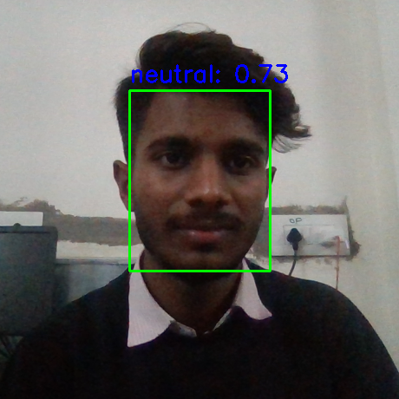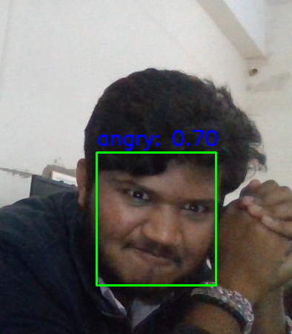

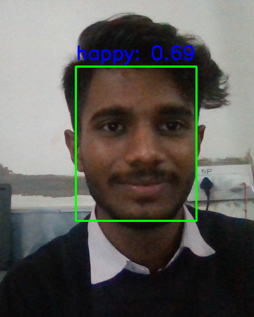

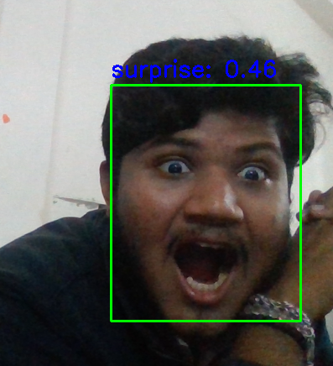

**CHAPTER-4**

**IMPLEMENT**

**Algorithm for Live Emotion Detection**

**Initialize Camera and Emotion Detector:**

Start capturing video from the default camera using cv2.VideoCapture(0).

Initialize the emotion detector using the FER library with MTCNN enabled for face detection.

**Start Live Video Capture:**

Begin an infinite loop to continuously capture frames from the camera.

**Capture Frame and Convert Colors:**

Read a frame from the video stream.

Convert the frame from BGR color space (used by OpenCV) to RGB color space (required by FER for emotion detection).

**Detect Emotions:**

Pass the RGB frame to the emotion detector's detect_emotions method.

Retrieve the list of detected emotions for any faces found in the frame.

**Process Detected Faces and Emotions:**

For each detected face:

Extract the bounding box that indicates the position of the face in the frame.

Retrieve the dictionary containing the probabilities for different emotions (e.g., happiness, sadness, etc.).

**Determine the Top Emotion:**

Identify the emotion with the highest probability for the detected face.

**Display Bounding Box and Emotion:**

Draw a rectangle around the face using the bounding box.

Display the top emotion and its probability above the bounding box using cv2.putText().

**Show the Frame:**

Show the updated frame (with the bounding box and emotion label) in a window titled "Live Emotion Detection."

### CHAPTER-5

### FLOWCHART

### Flowchart: Live Emotion Detection Using Deep Learning and Python

**Start-**

Begin the process.

**Initialize Libraries-**

Import necessary libraries (OpenCV, FER, NumPy).

**Set Up Webcam-**

Use cv2.VideoCapture(0) to initialize the webcam for video capture.

**Capture Video Frame-**

Continuously capture frames from the webcam.

**Convert Frame to RGB-**

Convert the captured frame from BGR to RGB format.

**Detect Faces-**

Use a face detection model (like MTCNN) to locate faces in the frame.

**For Each Detected Face-**

**a. Extract Face Region**

Crop the detected face from the frame.

b. **Analyze Emotion-**

Use the FER library to analyze the cropped face and predict the emotion.

**Display Emotion on Screen-**

Show the predicted emotion on the screen with a confidence score.

**Draw Bounding Box-**

Draw a bounding box around the detected face and label it with the emotion.

**Check for Exit Condition-**

a. If the user presses 'q', exit the loop.

b. Otherwise, go back to **Capture Video Frame**.

**Release Resources-**

Release the webcam and destroy any OpenCV windows.

**End-**

End the process.

### Visual Representation

If you need a visual representation, you can create this flowchart using tools like Lucidchart, Draw.io, or even PowerPoint, following the above structure.

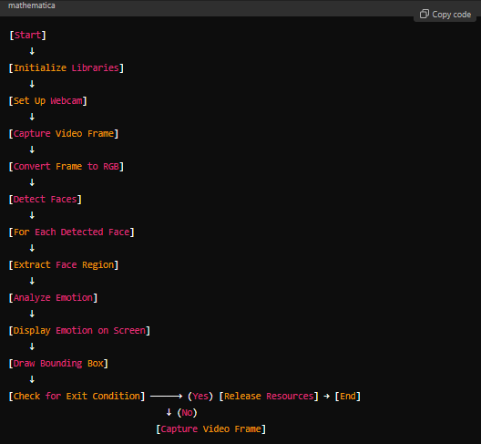

**CHAPTER-6**

**TOOLS AND LIBRARIES**

**Open CV** (Open Source Computer Vision Library) is a powerful and widely-used library designed for computer vision and image processing tasks. In this project, Open CV plays a crucial role in capturing video streams and processing images in real time.

**Video Capture**: The library provides the cv2.VideoCapture(0) method to interface with the default camera, allowing for seamless acquisition of video frames. Open CV supports various video sources, including webcams, video files, and streaming protocols, making it versatile for different applications.

**Color Conversion**: To facilitate emotion detection, Open CV converts the image from BGR (its default color format) to RGB. This conversion is vital because many deep learning models, including those used in the FER library, expect input in RGB format for accurate processing.

**Image Processing**: Open CV includes a variety of image processing functions, such as filtering, edge detection, and transformation operations. These functions can be employed to enhance the quality of the video feed or preprocess frames before feeding them to the emotion detection model.

**Real-Time Annotations**: Open CV provides tools to draw bounding boxes around detected faces, enhancing user engagement by visually highlighting the area of interest. It also allows for real-time annotations, such as displaying detected emotions directly on the video feed. This feature not only informs users about the emotional states being detected but also enhances the interactive nature of the application.

### FER (Facial Expression Recognition)

**FER** is a specialized Python library that employs deep learning models for detecting human facial expressions, making it an ideal choice for emotion recognition tasks.

**Facial Feature Analysis**: The FER library analyzes each captured frame to identify key facial features, such as the eyes, mouth, and eyebrows. By focusing on these features, the library can detect subtle changes in expressions that correlate with specific emotions.

**Emotion Classification**: FER categorizes emotions into distinct classes: happiness, sadness, surprise, anger, disgust, fear, and neutral. Its robust classification capabilities stem from training on large datasets that include diverse facial expressions, ensuring reliability across various demographics and environments.

**MTCNN Algorithm**: The library utilizes the **MTCNN (Multi-task Cascaded Convolutional Networks)** algorithm to detect faces in images accurately. This algorithm excels in identifying faces at different scales and angles, which is particularly beneficial in dynamic environments where users may move or change positions.

**Applications**: The effectiveness of the FER library extends to various applications involving emotion tracking and analysis based on facial cues. It is well-suited for real-time usage in tasks such as human-computer interaction, customer satisfaction analysis, educational engagement monitoring, and gaming, where understanding user emotions enhances overall experiences.

### Python

**Python** serves as the programming language for this project, chosen for its numerous advantages in the realm of computer vision and machine learning.

**Simplicity and Readability**: Python's straightforward syntax and readable code structure make it accessible for developers of all skill levels. This ease of use facilitates rapid development and testing of complex algorithms, promoting an agile approach to software design.

**Extensive Libraries**: Python boasts a rich ecosystem of libraries that streamline the integration of multiple functionalities. In this project, OpenCV is used for video processing, FER for emotion detection, and Matplotlib for data visualization. The ability to combine these libraries seamlessly enables efficient implementation of real-time applications.

**Community and Support**: Python has a large and active community, providing extensive resources, documentation, and support for developers. This community-driven approach fosters collaboration and innovation, allowing for continual improvements and updates to libraries and frameworks.

**Deep Learning Frameworks**: Python supports various deep learning frameworks such as TensorFlow and PyTorch, making it a go-to language for developing and deploying machine learning models. Its compatibility with these frameworks allows developers to leverage state-of-the-art algorithms and pre-trained models easily.

**Cross-Platform Compatibility**: Python's cross-platform capabilities enable applications to run on various operating systems without modification. This flexibility is particularly advantageous in developing software intended for diverse environments, whether on desktop systems or cloud-based platforms.

**CHAPTER-7**

**CONCLUSION**

This project successfully demonstrates a real-time emotion detection system using **OpenCV** and the **FER** library. The system is capable of identifying emotions in real time and displaying them on the screen, showcasing the effectiveness of combining computer vision with deep learning techniques. By integrating facial recognition with emotion detection, the project provides a robust foundation for future applications in various domains, including interactive systems, mental health monitoring, customer feedback mechanisms, and personalized user experiences.

The implications of this technology extend far beyond its current implementation. In interactive systems, for example, real-time emotion detection can enhance user engagement by allowing applications to respond dynamically to users' emotional states, fostering more meaningful interactions. In mental health monitoring, the system could serve as a supportive tool for therapists, enabling them to assess patients' emotional well-being and adapt treatment strategies accordingly. Furthermore, in marketing and customer service, understanding consumer emotions can inform strategies to improve satisfaction and loyalty, ultimately driving business success.

Future improvements may involve enhancing the accuracy of emotion detection by training the model on custom datasets tailored to specific demographics or applications. Expanding the system to detect multiple emotions simultaneously across different faces in a single frame would further increase its versatility and usability, particularly in environments like classrooms or social gatherings where multiple individuals' emotional states are relevant.

Moreover, incorporating additional UI elements and graphical representations can significantly enhance the user experience, making the system more intuitive and engaging. For instance, adding features like emotion history tracking, personalized feedback, or integration with other data sources (such as voice analysis) could provide richer insights into users' emotional patterns and behaviors.

As technology continues to evolve, the potential applications of emotion detection systems are vast and varied. This project serves as a stepping stone towards more advanced systems that leverage real-time emotion recognition, contributing to the development of emotionally intelligent machines that can understand and respond to human emotions more effectively. By prioritizing ethical considerations, such as user privacy and consent, the integration of such technologies can foster trust and acceptance in everyday applications, paving the way for a future where technology and human emotions are harmoniously intertwined.

In conclusion, the successful implementation of this real-time emotion detection system highlights the power of combining computer vision and deep learning, laying the groundwork for future innovations that enhance human-computer interaction and promote emotional awareness in various fields.

**CHAPTER-8**

**REFERENCES**

OpenCV Documentation: <https://opencv.org/>

FER Library: <https://github.com/justinshenk/fer/>

Source Code: <https://github.com/SWAROOP0007/swaru_mini_project.git/>